**Project Report**

**Ticket Reservation System of Wains Transport**

Submitted by

Talha Sajid

MCSE-19-35

2019-2021

Supervised by

Dr. Humaira Afzal



**DEPARTMENT OF COMPUTER SCIENCE**

**BAHAUDDIN ZAKARIYA UNIVERSITY MULTAN PAKISTAN**

**FINAL APPROVAL**

This is to certify that we have read this report submitted by **Talha Sajid** and it is our judgment that this report is of sufficient standard to warrant its acceptance by Bahauddin Zakariya University, Multan for the degree of MCS (Master of Computer Science).

# Committee:

**1. External Examiner ______________________**

Mr. Tahir Rashid  
Assistant Professor,  
Department of Computer Science  
COMSATS University, Vehari Campus

**2. Supervisor ________________**

**Dr. Humaira Afzal**  
Assistant Professor,  
Department of Computer Science

Bahauddin Zakariya University, Multan

**3. Head of Department ________________**

**Dr. Minhaj Ahmad Khan**  
Assistant Professor,  
Department of Computer Science

Bahauddin Zakariya University, Multan

**DEDICATION**

***To my Loving Parents,***

***Teachers and Friends***

**Acknowledgment**

First of all, thanks to Allah Almighty for his utmost blessings upon me and granting me courage and capability to complete the degree and especially this task. My sincere gratitude to my parents, family members and friends; they prayed for me and helped me whenever I needed. I wish to express thanks to my project supervisor for his constant motivation and valuable help during the project work. I also extend my thanks to other faculty members of the Department of Computer Science for their cooperation throughout my degree program.

**Talha Sajid**

**PROJECT BRIEF**

|  |  |
| --- | --- |
| PROJECT NAME | Ticket Reservation System of WAINS Transport |
| ORGANIZATION NAME | Department of Computer Science |
| UNDERTAKEN BY | Talha Sajid Chaudhary |
| SUPERVISED BY | Dr. Humaira Afzal |
| STARTING DATE | July 4th, 2021 |
| COMPLETION DATE | August 11th, 2021 |
| COMPUTER USED | Intel(R) Core (TM) i5-3340M CPU @ 2.70GHz, 8GB RAM, 128GB SSD, 320GB HDD |
| OPERATING SYSTEM | Windows 11 Pro |
| SOURCE LANGUAGE(S) | HTML, CSS, Java Script, jQuery, PHP |
| DBMS USED | MySQL |
| TOOLS/PACKAGES | MS Office 2019, Window’s Snipping Tool, Visual Studio Code, XAMPP. |

**Abstract**

Ticket Management System will help users to make online Reservation of WAINS Transport at any time. It will also help organization to digitalize their previously existing manual reservation system. Now admin will also be able to check all the statistics of buses, routes and reservations all at one place and also be able to print them easily. As for users they will also be able to cancel any of the existing reservations.

I would like to show my gratitude to **Dr. Humaira Afzal, Assistant Professor in the Department of Computer Science, BZU Multan** for giving me a good guideline for the project through his valuable & fruitful Consultations. I would like to expand my deepest gratitude to all those who have directly and indirectly guided me in writing this project including some of Wonderful Classmates.

**TABLE OF CONTENTS**

**Contents Page #**

Chapter 1

1.1 Introduction 9

1.2 Main Theme 9

1.2.1 Purpose 9

1.2.2 Objectives of the Project 9

1.3 Introduction to Organization 10

1.3.1 Mission Statement 10

1.3.2 Vision 10

1.4 Organization Setup 10

1.5 Hierarchy of Organization 11  
  
**Chapter 2**

2.1 Feasibility Study 14

2.1.1 Technical Feasibility 14

2.1.2 Economical Feasibility 14

2.2 Analysis 14

2.3 Understanding System 14

2.4 User Involvement 15

2.5 Data Gathering 15

2.5.1 Interviews 15

2.5.2 Observation 15

2.6 Existing System: Data Analysis 15

2.6.1 DFDs (Data flow Diagram) 16

2.7 Requirement Engineering 16

**Chapter 3**

3.1 Proposed System 18

3.1.1 Observation and Record Reviews 18

3.1.2 Objective of Proposed System 18

3.2 Advantages of Proposed System 19

3.3 Online Seat Booking 20

3.4 General DFD 21

3.5 DFD Reservation 22

3.6 System Design 23

3.6 Visual Modeling 24

3.6.1 Sequence Diagrams 24

3.6.2 Activity Diagrams 24

3.6.3 Use Case Diagram 25

3.6.4 Actor 25

3.7 Use Case of Admin 25

3.7.1 Login Use Case 26

3.7.2 Add/Delete Schedule Use Case 26

3.7.3 Add/Delete Bus Use Case 27

3.7.4 See Reservation Use Case 27

3.7.5 View Report Use Case 28

3.7.6 View Report Use Case 28

3.8 Use Case of Passenger 30

3.8.1 Login Use Case 30

3.8.2 Search Route Use Case 31

3.8.3 Reserve Seat Case 31

3.8.4 See Reservation Use Case 32

3.8.5 Print Ticket Use Case 33

3.8.6 Cancel Reservation Use Case 33

3.9 Sequence Diagram 34

3.9.1 Admin Login 34

3.9.2 Insert Schedule 35

3.9.3 Delete Schedule 36

3.9.4 Add Buses 37

3.9.5 Delete Buses 38

3.9.6 User Reservation 39

3.9.7 Search Route 40

3.10 Activity Diagram 41

3.11 ERD Diagram 42

3.12 Database Design 42

3.12.1 Advantages of Database 42

3.13 Key 43

3.13.1 Primary key 43

3.13.2 Super key 43

3.13.3 Composite key 44

3.13.4 Foreign key 44

3.13.5 Candidate key 44

3.14 Normalization 44

3.14.1 First Normal Form: (1NF) 45

3.14.2 Second Normal Form: (2NF) 45

3.14.3 Third Normal Form: (3NF) 45

3.15 Database Tables 46

3.15.1 Main Data Entries 46

3.16 Table Details 46

**Chapter 4**

4.1 Introduction 50

4.2 Tool / Language / Technology Selection 50

4.2.1 Front End 50

4.2.2 Back End 50

4.3 Operating system Selection 50

4.4 PHP 51

4.4.1 Advantages of PHP 51

4.5 Requirements Fulfilled by PHP 52

4.6 XAMPP Server 52

4.7 MY SQL 52

4.8 Java Script 53

4.9 Implementation 53

**Chapter 5**

5.1 Login Form 55

5.2 Register Form 55

5.3 Home Page 56

5.4 About Page 57

5.5 Booking Page 58

5.6 My Reservation Page 59

5.7 Printed Ticket 59

5.8 Admin Page 60

5.9 Report 61

**Chapter 6**

6.1 Conclusion 64

Chapter 1

INTRODUCTION

# 1.1 Introduction

Computer and Its Application Have Become an essential part of our life and are being used in almost every field of life. Since its invention it has served Humanity in every Possible way. Computer can Perform many supernatural tasks that appeared to be beyond the level of Human Thinking in the past. And with the help of Computers Great Progress have been made in Past couple of Years.

The Bus Management System of WAINS Transport is a web-based application that Allows Visitors to Check Bus Ticket Availability and Reserve Bus Ticket Online. This System Provides a Facility to reserve seats, Cancelling Reservation. Bus Management System of WAINS Transport Deals with the Maintenance of the record of each Passenger who has Reserved a Seat for Journey. It also Includes Maintenance of Information like Schedule and Details of each Bus.

# 1.2 Main Theme

This Project of Bus Management System of WAINS Transport is to Improve the Productivity of Company's Employees with the Objectives to Manage the Data on Every Bus Terminal and Make a website to Reserve Seats and Check the Travel Fares.

## 1.2.1 Purpose

The Purpose of this System is to Booking Online. Admin can Keep the Track of Every Passenger and Every Booking. Now it will not be necessary to go to Terminal you can just Visit the Website and Reserve Your Seats. It will Help to Computerize the Company and Build a Semi Computerized Ticketing System to Provide Better Services to the Costumers.

## 1.2.2 Objectives of the Project

The Foremost Objectives to be Achieved from the Bus Management System are

* Improving Ticket Reservation System
* Minimize Workload
* Eliminate the Paperwork
* Reducing the Chances of Error
* Improving Data Accuracy
* Assure Data Security and Data Safety
* Enhancing the Employee Productivity
* Facility to View all Details of Bus and Routes
* Provide Efficient Dataflow

# 1.3 Introduction to Organization

WAINS TRANSPORT is a Transport Organization. WAINS Transport was Established in 2009 and Expanded their Business to become a Dynamic Company in mid 2010s. It is well known across Whole Punjab with wide range of LUXURY Buses. It’s an Inter-City Bus Serving over 15 Destinations Across Whole Country.

## 1.3.1 Mission Statement

The Mission Statement of the Organization is “To Help People with Great Services and Serve their Costumers”.

## 1.3.2 Vision

*“Raise to the Destination with Satisfied Costumers”*

# 1.4 Organization Setup

This is Snapshot of overall Bus Management System of WAINS Transport. The System is Divided into Parts That work together in a coherent manner to achieve the System Objective.



Figure 1.1 *Bus Management System of WAINS Transport*

As Shown in Figure 1.1, the Management System of WAINS Transport is Divided into three Parts

1. User Site
2. Booking Site
3. Back End System

# 1.5 Hierarchy of Organization

The Next Thing is to Understand the Total Working of All the Staff Members of the Organization on different Level to Understand the Requirements of the Bus Management System.

Study of Organization on the Deeper Level will Allow us to Understand the Hierarchy in a Better way and Design the Web Based Application

It will Include All Levels of User which will have to Interact with the Application which will Include;

* Owner
* Manager
* Terminal Head
* Staff
* End Users/Costumers

The Hierarchy of Organization is Shown in the Figure 1.2 Below.

Chapter 2

SYSTEM ANALYSIS

# 2.1 Feasibility Study

This phase deals with the determination of problem and its solution; either is feasible or not going through this phase some interviews were made with the management to ﬁnd out the requirements of the organization.

## 2.1.1 Technical Feasibility

The system which is to be developed is web-based. Php along with MySQL server will be used to develop it. The project will be designed in the way that it is easy to use and enhance productivity.

## 2.1.2 Economical Feasibility

There is no need for purchasing the tool and license used during the development of the project. All tool and technologies that are required during the development already exists for free and are open source so can be used by anyone. This makes the development economically feasible. Only costing factor is the effort and time that is utilized in project development.

# 2.2 Analysis

The analysis phase is primarily concerned with studying the existing system, after analysis of the existing system, we can design and implement better user-friendly computerized system.

# 2.3 Understanding System

The Most Important thing for a Successful Computerize System is Proper Understanding of the Existing System. And There is No Current Web Based Application of WAINS TRANSPORT.

# 2.4 User Involvement

The most successful project or system is those in which user play an active and vital role. The user knowledge of the organization is needed for a new system. Because it's a user who have to use the new system and he is the best person who can give the reliable and useful information.

# 2.5 Data Gathering

Data is gathered by many ways but I choose the following techniques:

## 2.5.1 Interviews

Interviews were conducted to retrieve the qualitative information. These interviews, provided opportunity to gather information from the respondents who are involved in the process for a long time. In this method interviews are conducted to the Wains Transport users and organization staff for data gathering.

## 2.5.2 Observation

To gather Details about the booking management, few kinds of record and reports were reviewed. This Study covers

* Standard operating procedure.
* How to record the order.
* How to generate the report.

# 2.6 Existing System: Data Analysis

Data analysis is a practice of science for examining the raw data to get organized so that useful information can be extracted from it. There are a several data analysis methods including establish questions, visualize data, statically analysis.

## 2.6.1 DFDs (Data flow Diagram)

A data-flow diagram (DFD) is a way of representing a flow of a data of a process or a system (usually an information system). DFD describes the processes that are involved in a system to transfer data from the input to the file storage and reports generation. The DFD of Timetable management system involve such processes to occur.

# 2.7 Requirement Engineering

As we go to develop a new system now it is time to determine the new requirements for the new system. As the user is the most important part of any system it is required to find the users requirements to develop a user-friendly system rather than having to develop a developer friendly system. For Bus Management System of WAINS TRANSPORT requirements are as follows.

* Easily View reports of booking.
* Customers will be able to place orders through Website Interface.
* Account Creation.
* Customers get information and location of the WAINS Transport terminal.
* Here Administrator manage Booking, Schedule Records, Bus Records etc.

Chapter 3

System Design

# 3.1 Proposed System

The proposed system will be completely a computerized system. All the input data will be properly organized and stored, and will process for the required output to provide timely information. Proposed system will have the all activities describe in the existing system as drawback and will provide necessary information with accuracy and efficiency. The proposed system has suggested is very sophisticated and is capable for any kind of future modification. Rajput Travels Company facilitate to their passenger. In case of cancelation, in spite of physical conduct, he may do the process through online.

Proposed system is completely graphically interfaced. It is so user friendly that a common man can easily use it. It is most important that it's fulfilling the user requirements for a successful system.

## 3.1.1 Observation and Record Reviews

It is most important that it's fulfilling the user requirements for a successful system. Mostly projects fail because of unreasonable expectations attached to them. Therefore, the user expectations should clearly be defined. The main goal of this project is to design and implement complete online & computerized system that fulfills all requirements of the distribution system for the system to be developed, the following are proposed features. Proposed system should be easy to use.

* Fast and easiest access to the required information.
* Ensure security and protection of data.
* Be more efficient than existing system.
* There should be a system having data integrity and data consistency.

## 3.1.2 Objective of Proposed System

The most successful projects are those that truly work according to their expected. So, user expectation must be defined. The user involvement plays important role in the development of any project. The requirements for the system have been gathered from the defects recorded in the past and also based on the feedback from users of previous metrics tools. The following are the major objectives which have chosen before designing the proposed system.

* The proposed system should provide better management control of the Booking and Reservation of seats.
* The trained computer staff will not be required for the prescribed system to make it user friendly for users.
* The new system will definitely improve the graph sales and improve the
* output of the Organization. As current era is fast and the users need response without wasting time:
* The Proposed system handled reservation, printing tickets, seats availability facility and reports of routes.
* Facilitates passengers to book his/her seats from anywhere through website.

# 3.2 Advantages of Proposed System

The proposed system has many features some of them are discussed as following:

1. Efficiency

Efficiency is the degree to which we maximize utilization of resource for achieving an objective. The proposed system will be more efficient and usable than existing manual system.

2. Data Security

The data required for decision making is highly sensitive. Therefore, reliability of proposed system is secured by giving regular and guaranteed services to user.

3. Accuracy

The system will provide flawless and accurate information needed for decision-making. It will ensure efficient and accurate record keeping.

4. Reliability

The new system will be reliable than the existing one due to security and accuracy so that timely decision making will be possible.

5. Flexibility

The system will allow for changing to incorporate in future requirements of the management, as well as it provide better understanding of system and user.

6. Performance

The proposed system should reduce the time and efforts required to retrieve information. It should have the capability to answer various queries instantly and efficiently.

7. Minimize Redundancy

The proposed system has been so that minimum data is duplicated in files. So it has minimized redundancy. that increases overall performance of a system and provide better results.

8. User Friendly

System will be friendly and user will communicate with the system easily. No specialized training will be required to learn the system before use.

9. Comprehensive Database

The proposed system will have comprehensive database on which facilities of insertion, modification, and other facilities of various queries and report are available.

# 3.3 Online Seat Booking

* First of all, customer is registered to Main page of site.
* Customer login in with his User Name and Password.
* Give origin and destination where he/she wants to travel.
* System will display all possible route timings according to user input. Customer selects the suitable timing to travel.
* Select seat if available.
* Ticket will be print online

# 3.4 General DFD

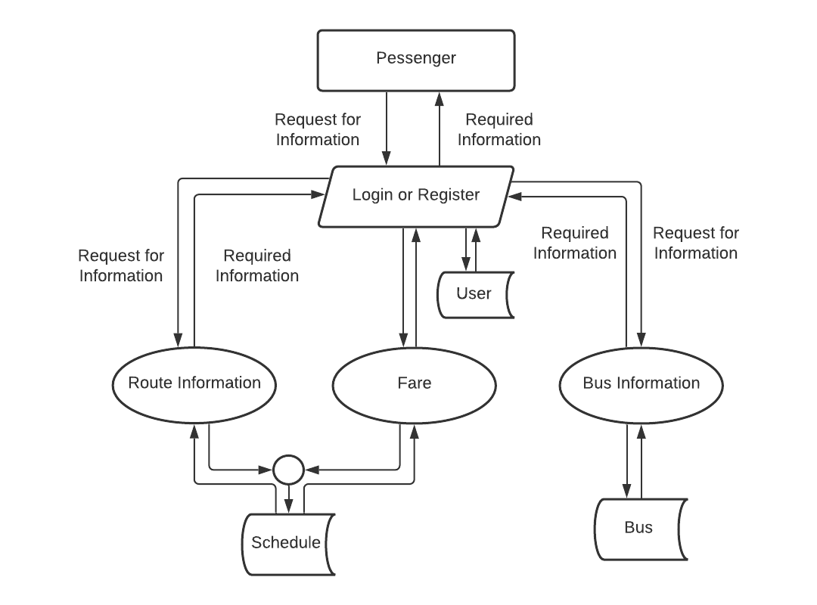

# 3.5 DFD Reservation

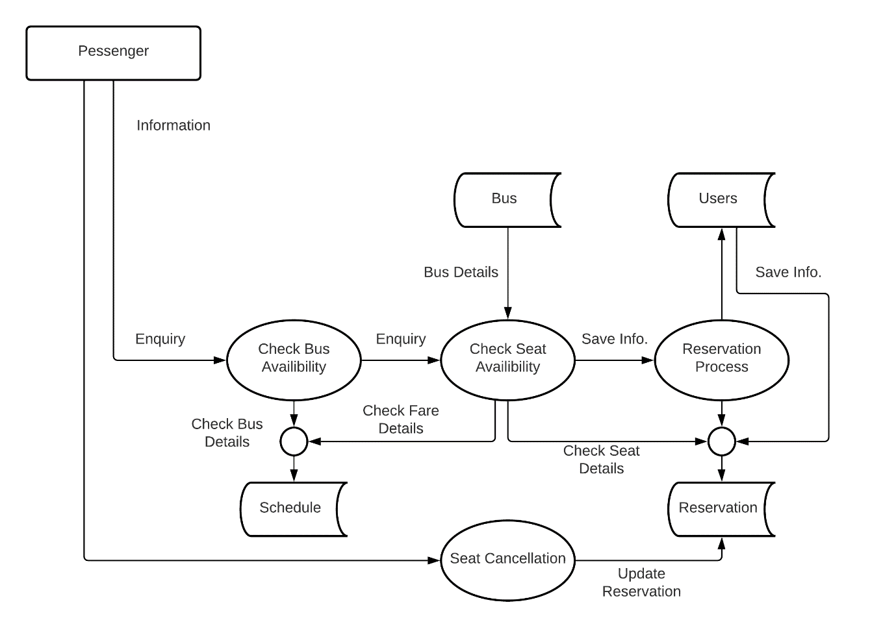

# 3.6 System Design

System design lies at the core of the software engineering process and is applied regardless of the software process model that is used for development. Design simulation serves as the foundation in the computer-based development is a time-consuming task. Beginning from computer-based system requirements analysis, system design is the first of three technical activities i.e., design, code generation and test that are required to build and verify the validate computer-based system. The major goals of the design phase are the creation of a system that provides certain predefined functions, reliability of system, flexibility. maintainability, efficiency and security. After the comprehensive study of the existing system, then the developer designs a new system, which fulfils all the requirements of the organization. Design is only way that we can accurately translate a company and passenger's requirements in to a computer-based system. Computer base system design serves as the foundation for all software engineering and maintenance steps. Design phase is compiled with the objective of reducing the problems present in the existing system.

The design of the project is user friendly. The names of database tables and fields are simple and easy to understand. In database design, the database tables and fields are developed after careful consideration of existing system to avoid redundancy and hence the errors. User interface is designed very carefully by keeping in mind the ease of user. Any new user can easily understand the system. System provides security to prevent illegal access. The interface design describes how the computer-based system communicates within itself, to systems that operate with it, and with humans who use it. An interface implies a flow of information. This phase deals with the design of system which consists of following design considerations:

* Software Design
* Database Design
* User Interface Design

# 3.6 Visual Modeling

Visual modeling is the process of taking the information from the model and displaying it graphically using some sort of standard set of graphical elements. A standard is vital to realizing one of the benefits of visual modeling communication. Communication between users, developers, analysts, testers, managers and anyone else involved with a project is the primary purpose of visual modeling. UML is a standard that has been adopted by majority of the industry as well as the standards governing boards such as ANSI and the Object Management Group (OMG). UML allows people to develop several different types of visual diagrams that represent various aspects of the system. Rational Rose supports the development of the majority of these models, as follows:

* Sequence Diagram
* Use Case Diagram
* Activity Diagram

## 3.6.1 Sequence Diagrams

Sequence diagrams are used to show the flow of functionality through a use case. Actors and objects are shown at the top of the diagram. Each arrow represents a message passed between actor and object or object and object to perform the needed functionality. It depicts the objects and classes involved in the scenario and the sequence of messages exchanged between the objects needed to carry out the functionality of scenario.

## 3.6.2 Activity Diagrams

Activity diagrams are used to show the flow of an activity. Each action is shown at the top of the diagram. Each arrow represents a message passed between actor and object or object and object to perform the needed functionality. It depicts the objects and classes involved in the scenario and the sequence of actions between the objects needed to carry out the functionality.

## 3.6.3 Use Case Diagram

Use Case diagrams show the interaction between use cases, which represent system functionality, and actors, which represent the people or systems that provide or receive information from the system. Use cases represent the requirements of the system from the user's perspective. So, use cases are the functionality that the system provides. Actors are the end users of a system.

## 3.6.4 Actor

# 3.7 Use Case of Admin

## 3.7.1 Login Use Case

The Name of the use case is “Login”.

Description

The use case is used when admin open the Administrator site.

Actor

The Administrator and the registered users are the actor in this case.

Precondition

The Administrator and the computer operator must be registered into the system before entering this stage.

Normal Flow of Events

* Admin Login to the main page of the admin site.
* Admin Enters the username and password.
* Admin gets the message for providing the wrong information.
* Admin Enters the correct Username and Password.
* Now Admin is able to use the system.

Post Condition

Administrator Login Successfully.

## 3.7.2 Add/Delete Schedule Use Case

The Name of the use case is “Add/Delete Schedule”.

Description

The use case is used when admin Enters or deletes the schedule.

Actor

The Administrator and the registered users are the actor in this case.

Precondition

The Administrator must be login.

Normal Flow of Events

* Admin Login to the main page of the admin site.
* Clicks on the “Add schedule” button to add a new schedule.
* Then Enters all the required data and click “Add” button.
* Admin than click on “View Schedule” button to view all the schedule.
* Now Admin can also delete any of the existing schedule.

Post Condition

New Schedule will be added or the existing schedule will be deleted.

## 3.7.3 Add/Delete Bus Use Case

The Name of the use case is “Add/Delete Bus”.

Description

The use case is used when admin Enters or deletes the Bus.

Actor

The Administrator and the registered users are the actor in this case.

Precondition

The Administrator must be login.

Normal Flow of Events

* Admin Login to the main page of the admin site.
* Clicks on the “Add Bus” button to add a new bus.
* Then Enters all the required data and click “Add” button to save data.
* Admin than click on “View Bus” button to view all the buses.
* Now Admin can also delete any of the existing buses.

Post Condition

New Buses will be added or the existing buses will be deleted.

## 3.7.4 See Reservation Use Case

The Name of the use case is “See Reservation”.

Description

The use case is used to check the Reservations.

Actor

The Administrator and the registered users are the actor in this case.

Precondition

The Administrator must be login.

Normal Flow of Events

* Admin Login to the main page of the admin site.
* Clicks on the “Dashboard” button to view the Recent Reservations.
* Here Admin can also see all the Recent Customers who have reserved the seat in the bus.

Post Condition

Can See all the reservations and the recent Customers.

## 3.7.5 View Report Use Case

The Name of the use case is “View Report”.

Description

The use case is used to check the Report.

Actor

The Administrator and the registered users are the actor in this case.

Precondition

The Administrator must be login.

Normal Flow of Events

* Admin Login to the main page of the admin site.
* Clicks on the “Report” button to view the Report of Reservations.
* Here Admin can also apply different filters to see report via specific date or specific route or specific bus.

Post Condition

Can See the Report.

## 3.7.6 View Report Use Case

The Name of the use case is “Print Report”.

Description

The use case is used to print the Report.

Actor

The Administrator and the registered users are the actor in this case.

Precondition

The Administrator must be login.

Normal Flow of Events

* Admin Login to the main page of the admin site.
* Clicks on the “Report” button to view the Report of Reservations.
* Here Admin can also apply different filters to see report via specific date or specific route or specific bus.
* Then click the print button to print the report.

Post Condition

Can get the Printed Report of the reservation.

# 3.8 Use Case of Passenger

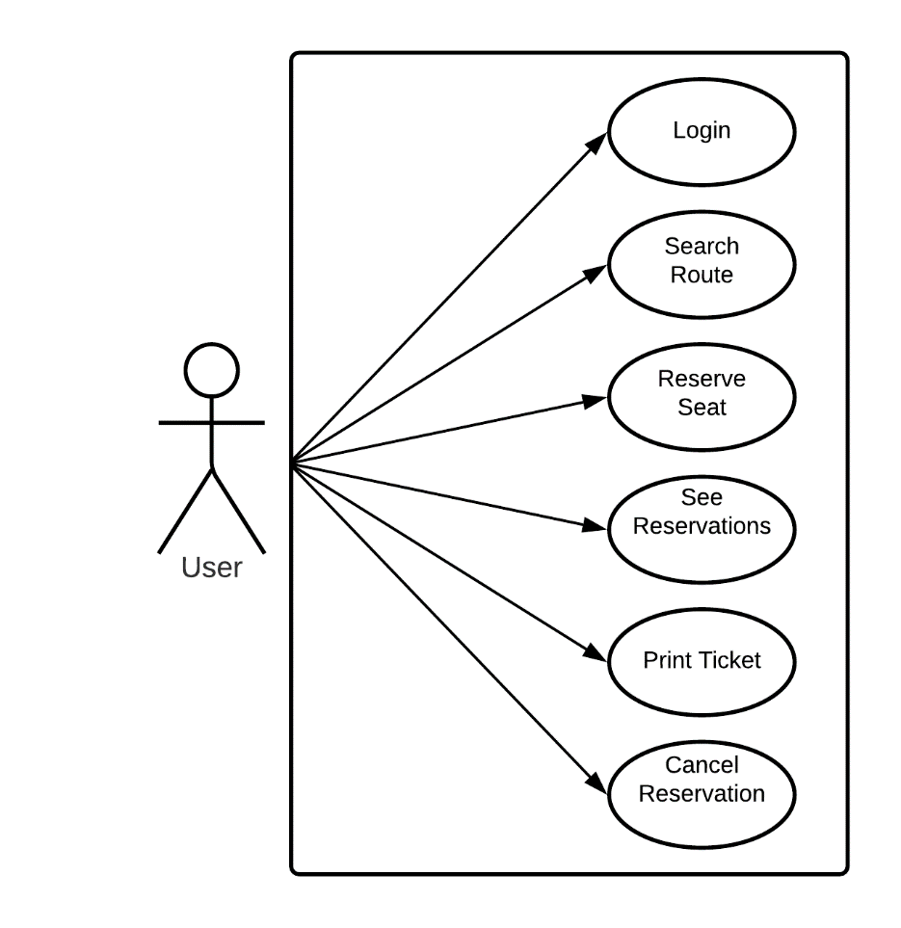

## 3.8.1 Login Use Case

The Name of the use case is “Login”.

Description

The use case is used when User open the User site.

Actor

The Users/Passengers are the actors in this case.

Precondition

The Users and the computer operator must be registered into the system before entering this stage.

Normal Flow of Events

* User Login to the main page of the admin site.
* User Enters the username and password.
* User gets the message for providing the wrong information.
* User Enters the correct Username and Password.
* Now User is able to use the system.

Post Condition

User or Login Successfully.

## 3.8.2 Search Route Use Case

The Name of the use case is “Search Route”.

Description

The use case is used when User open the User site.

Actor

The Users/Passengers are the actors in this case.

Precondition

The Users and the computer operator must be registered into the system before entering this stage.

Normal Flow of Events

* User Login to the main page of the admin site.
* User Enters the Origin and the Destination.
* User then clicks the “Search” button.
* User gets all the buses for the required route.

Post Condition

User gets the required buses for the route.

## 3.8.3 Reserve Seat Case

The Name of the use case is “Reserve Seat”.

Description

The use case is used when User open the User site.

Actor

The Users/Passengers are the actors in this case.

Precondition

The Users and the computer operator must be registered into the system before entering this stage.

Normal Flow of Events

* User Login to the main page of the admin site.
* User now got all the available buses for the required origin.
* User then clicks the “Book Now” icon.
* User seat is now reserved.

Post Condition

User Reserves seat in the bus Successfully.

## 3.8.4 See Reservation Use Case

The Name of the use case is “See Reservation”.

Description

The use case is used to check the Reservations.

Actor

The User is the actor in this case.

Precondition

The User must be login.

Normal Flow of Events

* User Login to the main page of the admin site.
* Clicks on the “My Reservation” button to view the Reservations.
* Here Users can see his/her reservations.

Post Condition

Can See all the Reservations.

## 3.8.5 Print Ticket Use Case

The Name of the use case is “Print Ticket”.

Description

The use case is used to Print Ticket.

Actor

The User is the actor in this case.

Precondition

The User must be login.

Normal Flow of Events

* User Login to the main page of the admin site.
* Clicks on the “My Reservation” button to view the Reservations.
* Click Print Icon to print the reserved ticket.

Post Condition

User gets the Printed Ticket.

## 3.8.6 Cancel Reservation Use Case

The Name of the use case is “Cancel Reservation”.

Description

The use case is used to Cancel Reservation.

Actor

The User is the actor in this case.

Precondition

The User must be login.

Normal Flow of Events

* User Login to the main page of the admin site.
* Clicks on the “My Reservation” button to view the Reservations.
* Click Delete Icon to Cancel the reserved ticket.

Post Condition

User cancels the reservation.

# 3.9 Sequence Diagram

All the Sequence Diagrams of Admin and Users are as follow

## 3.9.1 Admin Login



## 3.9.2 Insert Schedule

## 3.9.3 Delete Schedule



## 3.9.4 Add Buses

## 3.9.5 Delete Buses



## 3.9.6 User Reservation



## 3.9.7 Search Route



# 3.10 Activity Diagram



# 3.11 ERD Diagram

# 3.12 Database Design

In the design phase the most important process is database design. In database designing

different normalized tables are formed then relationship between these normalized tables is

described. After studying the existing system, it is decided to develop normalized tables for

the database designs. Before describing the tables, it is better to understand the concept of

Normalization and the different forms of normalization.

## 3.12.1 Advantages of Database

The most common advantage of data base as follows

* Minimal data redundancy
* Consistency of data
* Data integrity
* Sharing of data
* Ease of application development
* Reduced program maintenance

Constraints

These are condition that obey data base

Entity

Any object of concept identified by an enterprise that exist independently and about which it is necessary to store data. It may be anything like a person, a place, an event or object.

Attributes

An attribute is the characteristics or property of an entity that is of interest to the organization. For example, student is an entity; its attribute mostly may be student roll no, name, address, marks.

# 3.13 Key

A key is a distinct for each individual is an entity set. Key attribute are the attributes whose values are uniquely identified and do not exist.

## 3.13.1 Primary key

A primary key is a special relational database table column (or combination of columns) designated to uniquely identify all table records. A primary key's main features are. It must contain a unique value for each row of data. It cannot contain null values.

## 3.13.2 Super key

A super key is a set of attributes within a table whose values can be used to uniquely identify a topple. A candidate key is a minimal set of attributes necessary to identify a topple; this is also called a minimal super key.

## 3.13.3 Composite key

A composite key is a combination of two or more columns in a table that can be used to uniquely identify each row in the table when the columns are combined uniqueness is guaranteed, but when it taken individually it does not guarantee uniqueness.

## 3.13.4 Foreign key

In the context of relational databases, a foreign key is a field (or collection of fields) in one table that uniquely identifies a row of another table or the same table. In simpler words. the foreign key is defined in a second table, but it refers to the primary key or a unique key in the first table.

## 3.13.5 Candidate key

A candidate key is a column, or set of columns, in a table that can uniquely identify a database record without referring to any other data. Each table may have one more candidate key, but one candidate key is unique, and it is called the primary key.

# 3.14 Normalization

There three main forms of normalization these forms have their own definitions. These are stated as follow:

The normalization is to produce a stable set of relation that is faithful model of the operation of the enterprise. By following the principles of normalization, we can achieve the purpose of design that is highly flexible, allowing the model to be extended when needed to account for new attributes, entity sets and relationships. We can also reduce redundancy in the database and ensure that the design is free of certain update, insertion and deletion anomalies.

## 3.14.1 First Normal Form: (1NF)

A relationship is in first normal form if and only if every attribute is single valued for each table, in other words we can say that each attribute in each row or each cell of the table is atomic or single valued. Since each attribute is single valued for each topple we say that the tables are in first normal form (INF).

## 3.14.2 Second Normal Form: (2NF)

A relationship is in second normal form if and only if it is in first normal form and all non- key attributes are fully functionally dependent on the key. If relationship is in first normal form and key consists of single attribute, the relationship is automatically in second normal form. The only case we have to concern about second normal form is when the key is composite. If there are no composite keys in the tables then so the relations are in second normal form (2NF).

## 3.14.3 Third Normal Form: (3NF)

A relationship is in third normal form if it is in second normal form and no non-key attributes transitively dependent on key. Since the table are in second normal form and non-key attribute is transitively dependent on key i.e. no non-key attribute is determined another non-key attribute. So, the tables are in third normal form. I would describe it in my words as if no non-key attribute is depending on other non-key attribute then the relationship is in third normal form (3NF).

# 3.15 Database Tables

## 3.15.1 Main Data Entries

|  |  |
| --- | --- |
| **Entities** | **Description** |
| Admin | Administrator of the Organization. |
| Customer | Passengers Detail. |
| Route | Detail about Route. |
| Schedule | Bus Schedule Detail. |
| Booking | Detail of Reserved Seats. |

# 3.16 Table Details

All the Details of the Tables used in database during this project are as follow

**Table Name: User**

**Description: Contains all the data about the Customers.**

**Primary Key: UserId is the Primary Key.**

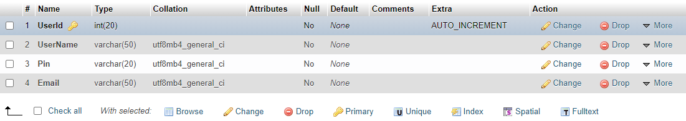

## ****Table Name: Schedule****

## ****Description: Contains all the data about the Schedule of Buses.****

## ****Primary Key: ScheduleId is the Primary Key.****

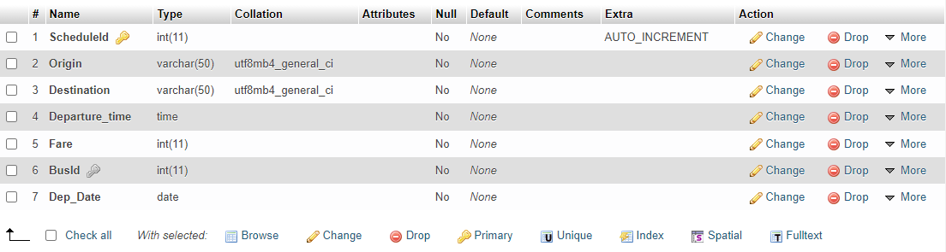

## ****Table Name: Schedule****

## ****Description: Contains all the data about the Schedule of Buses.****

## ****Primary Key: ScheduleId is the Primary Key.****

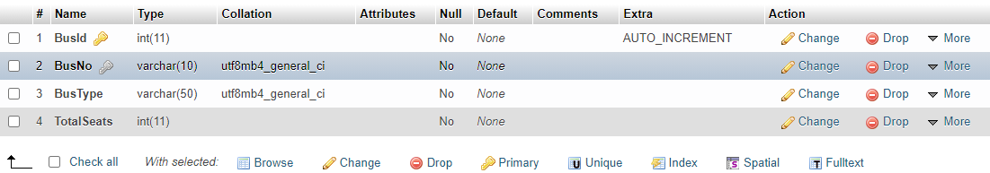

## ****Table Name: Reservation****

## ****Description: Contains all the data about the Reserved Seats.****

## ****Primary Key: ReservationId is the Primary Key.****

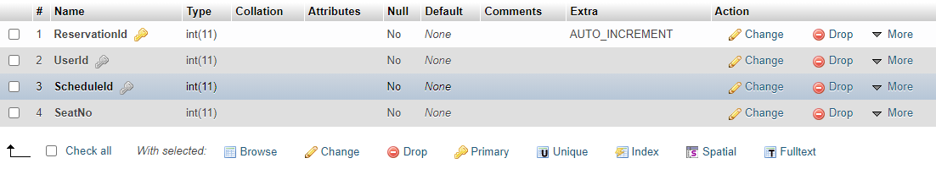

Chapter 4

System Development and Implementation

# 4.1 Introduction

Once the system is proposed and the analysis and design phase has been accomplished, the designer moves towards the development phase of the software in accordance with the proposed system and design phase specification. It is more practical because it involves the realization of the actual system. Computer programs are written and arrangements are made to train the personal.

# 4.2 Tool / Language / Technology Selection

Different tools and language have been selected for the development and implementation of this project which is as follows:

## 4.2.1 Front End

The front end is that part of the software, which is visible to all the user interactions takes place at the front end. Since the project is web-based therefore the front end is designed in the language that a browser can understand therefore this end is designed using HTML.

## 4.2.2 Back End

The back end is that portion of the project where the database is maintained. For the creation and maintenance of the database, we need a DBMS. The DBMS selected for this project is MYSQL.

# 4.3 Operating system Selection

An operating system should be chosen that fulfils the requirements of the software and is available to the users easily. The operating system was not a very difficult task for me in this application. So, it was important for me to select a properly operating system that would support this application. It is most appropriate to use Windows 7, Windows 10 and Windows 11. So, I selected **Windows 11** for my application.

The selection of an appropriate language is of vital importance. A language should be selected keeping in view both the requirements and the nature of the project. Whatever language is selected it should support the desired programming tasks.

# 4.4 PHP

PHP is an open-source server-side scripting language that is very similar in syntax to C languages. Although originally designed to run under Linux using the Apache Web server, it has been ported to work using virtually every operating system and any standards-compliant Web Server software. From this, we can derive three of the primary advantages of PHP.

## 4.4.1 Advantages of PHP

Easy to use:

It uses C like syntax, so for those who are familiar with C, it’s very easy for them to pick up and it is very easy to create website scripts.

Flexibility:

PHP also offers great flexibility during and after the initial project. This is important since functionality often changes during a project’s lifetime. A great thing about PHP is that we can implement changes even after starting development, without losing valuable time.

Platform independent:

It can be run on all major operating systems like Linux, UNIX, Mac OS, and Windows.

Support all major Databases:

It supports all major databases including MySQL, dBase, IBM DB2, Inter Base, Front Base, ODBC, SQLite, etc.

# 4.5 Requirements Fulfilled by PHP

Firstly, there are build-in libraries for the direct creation and manipulation of images and PDF documents. This means, for example, that if an application calls for dynamically created menu images with anti-aliased text or the exporting of pages to Acrobat format, PHP may be the ideal technology to do it. Although these features are theoretically available in competing technologies, they usually require the installation of third-party custom components to do so. Another situation that may make PHP the best choice of server scripting is where connecting to either MySQL or PostgreSQL database is required.

# 4.6 XAMPP Server

XAMPP is a free and open-source cross-platform web server solution stack package developed by Apache Friends, consisting mainly of the Apache HTTP Server, MariaDB database, and interpreters for scripts written in the PHP and Perl programming languages

The term XAMPP is an apparent acronym. However, there is no official acronym expansion specified on the Apache Friends website. Their homepage header reads "XAMPP Apache + MariaDB + PHP + Perl", indicating that this abbreviation is a recursive acronym.

# 4.7 MY SQL

MY SQL is a multithreaded, single-user SQL database management system (DBMS) which has more than 11 million installations. The program runs as a server providing multi-user access to several databases.

MYSQL is popular for web applications and acts as the database component of the LAMP, MAMP, and WAMP platforms. MYSQL works on many different platforms.

# 4.8 Java Script

JavaScript is a special language used in many web sites. A scripting language is a language, which is easy and fast to learn. A scripting language is interpreted in run-time. It is not compiled like other languages like C++, C#, VB.NET, etc. JavaScript is a client-side language and it runs on the client browser. Netscape developed it and because of its simplicity. It is one of the most known scripting languages. It can also be used on the server-side. Java Script can be used on all most known browsers. It can be easily used to interact with HTML elements. We can validate text fields, disable buttons, validate forms, or change the background colour of the page. like each programming language, it contains variables, arrays, functions, operators, objects, and much more which can help us to create better scripts for our pages. On the server-side, we can use JavaScript for example to manage our database entry. JavaScript code can be inserted directly in the HTML or we can place it in a separate file with JS extension and link the webpage with the JS file.

# 4.9 Implementation

A crucial phase in system design is the successful implementation of a new employee management system. Implementation means the process of assuring that the information system is operational and then allows users to take over its operations for use and evaluation. The implementation simply means converting a new system into an operational system, to install into an organization and then allow the user to build a properly operational system.

For implementation, there are three processes

* Select a Domain Name
* Purchase Domain/Get Register your Domain
* Register Domain
* Host Website

Chapter 5

User’s Guide

# 5**.1 Login Form**

# 5.2 Register Form

# 5.3 Home Page

# 5.4 About Page

# 5.5 Booking Page

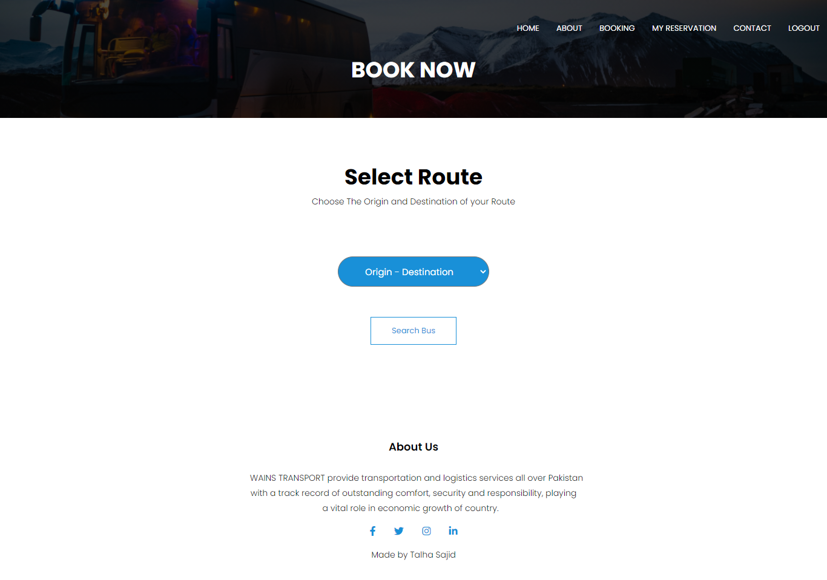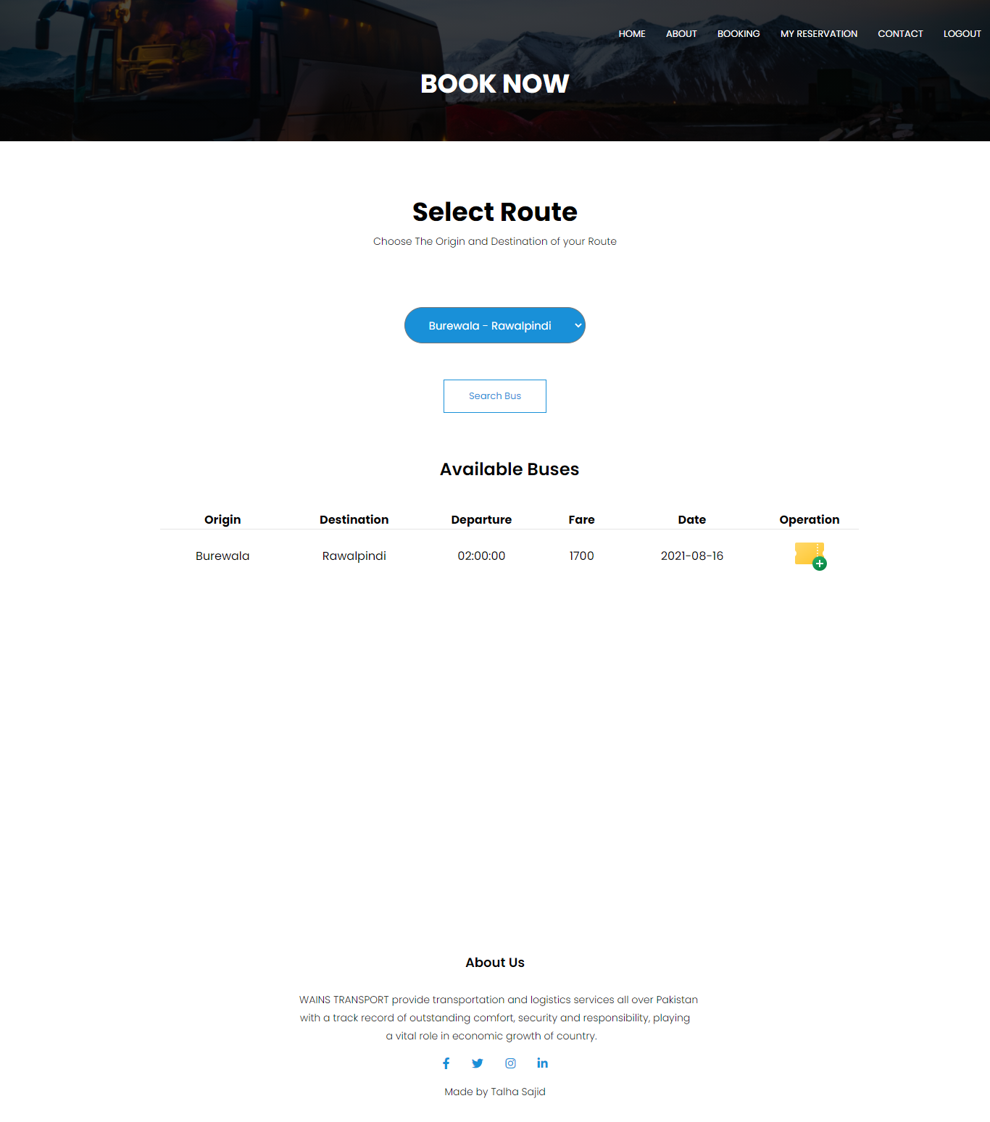

# 5.6 My Reservation Page

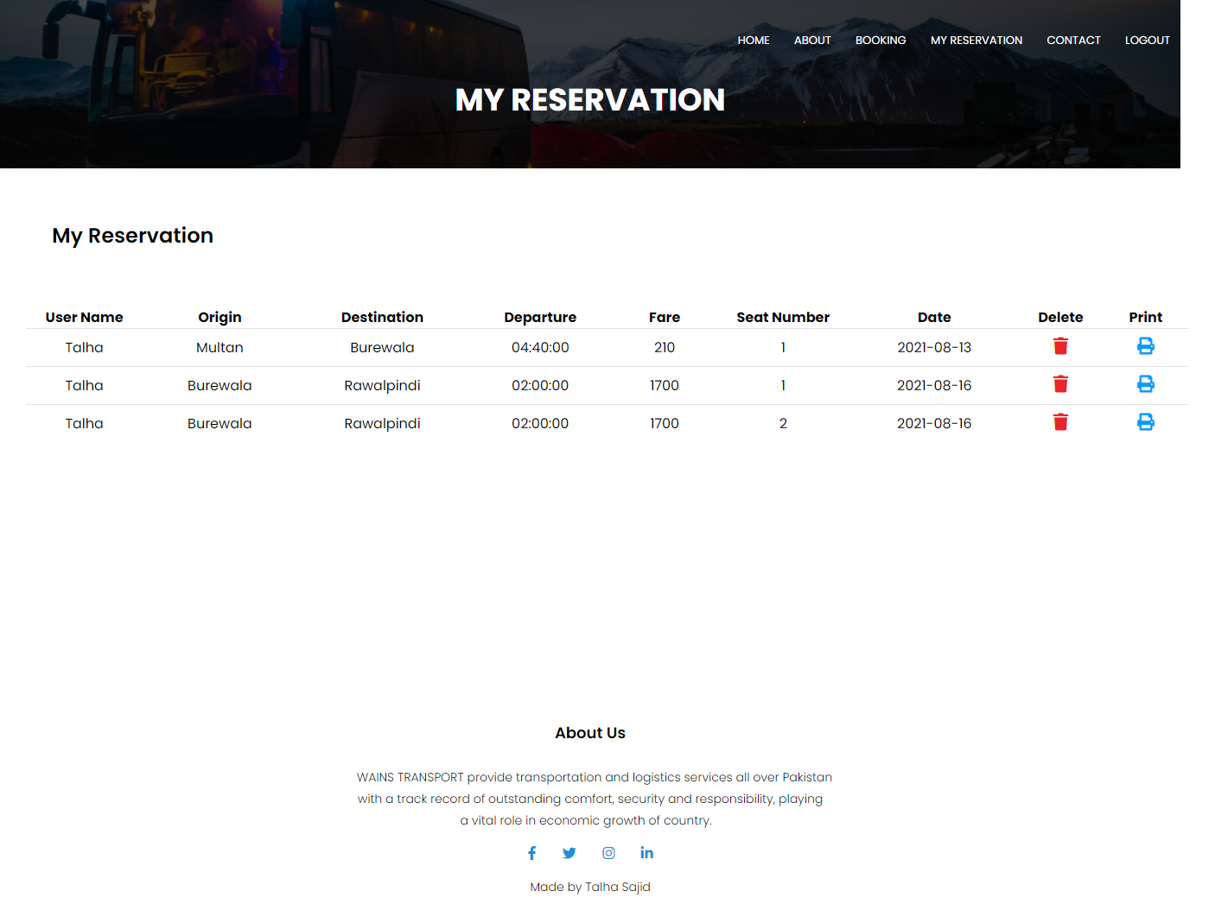

# 5.7 Printed Ticket

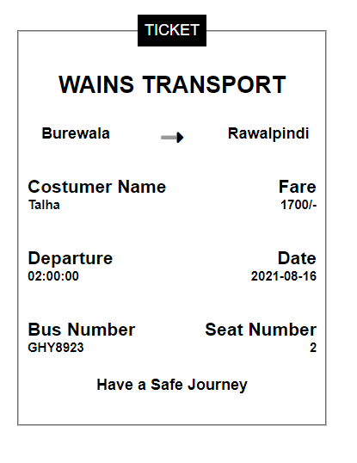On Clicking print icon ticket will be printed

# 5.8 Admin Page

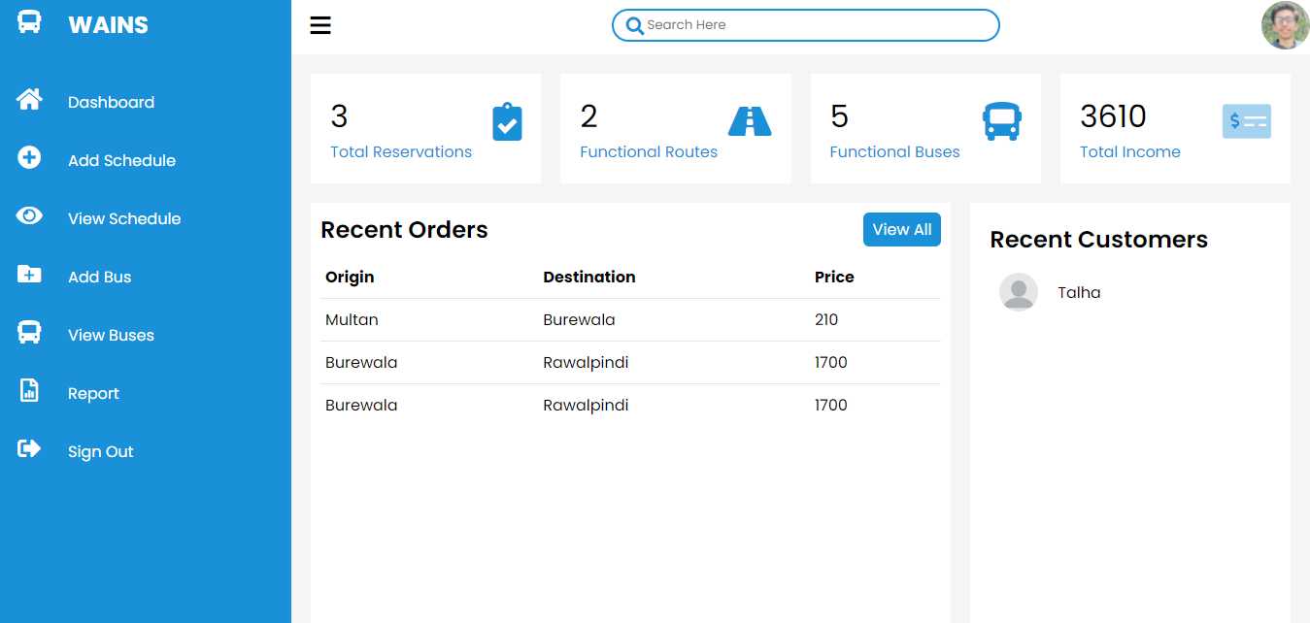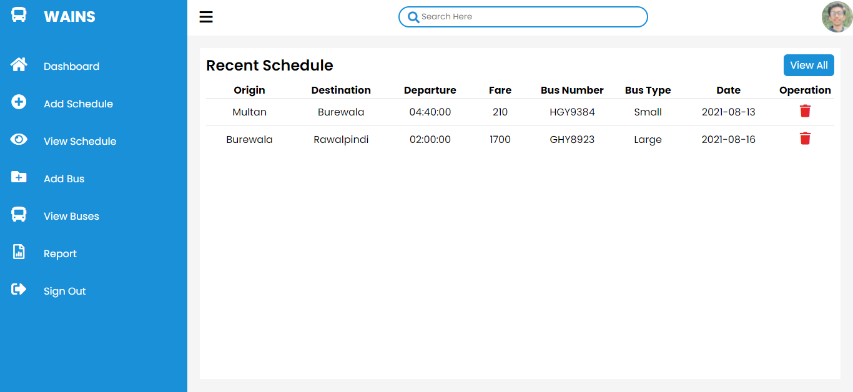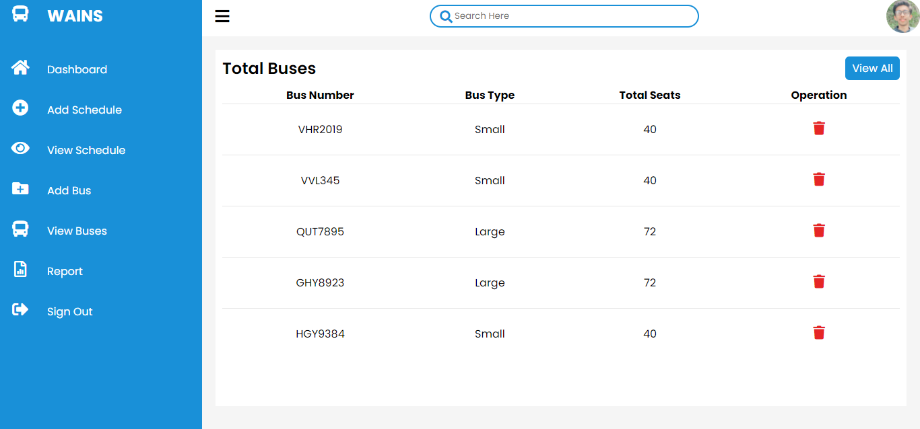

# 5.9 Report

Admin can get reservation report via 3 different preferences.

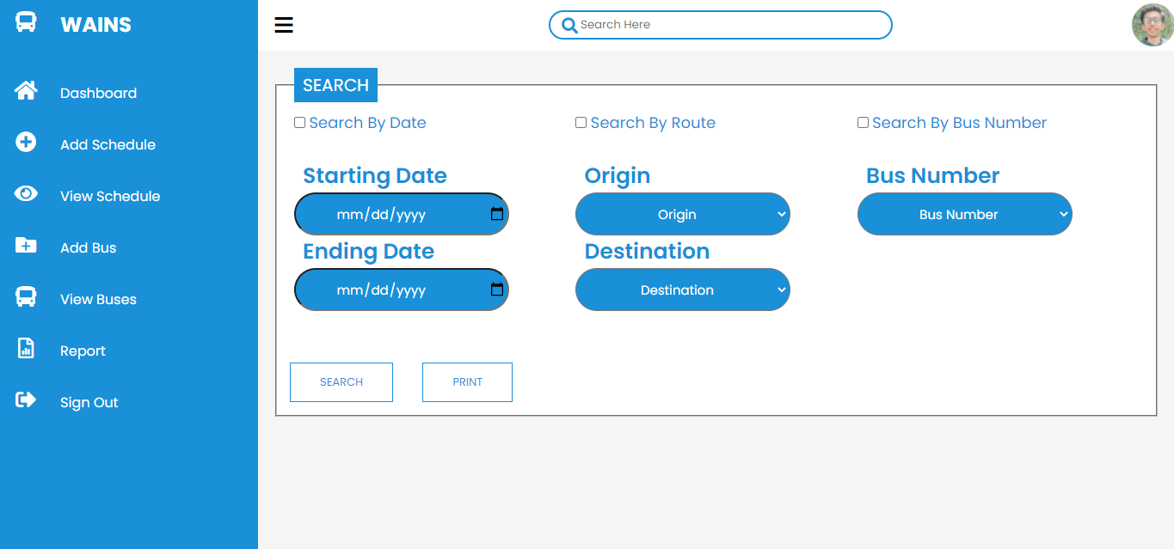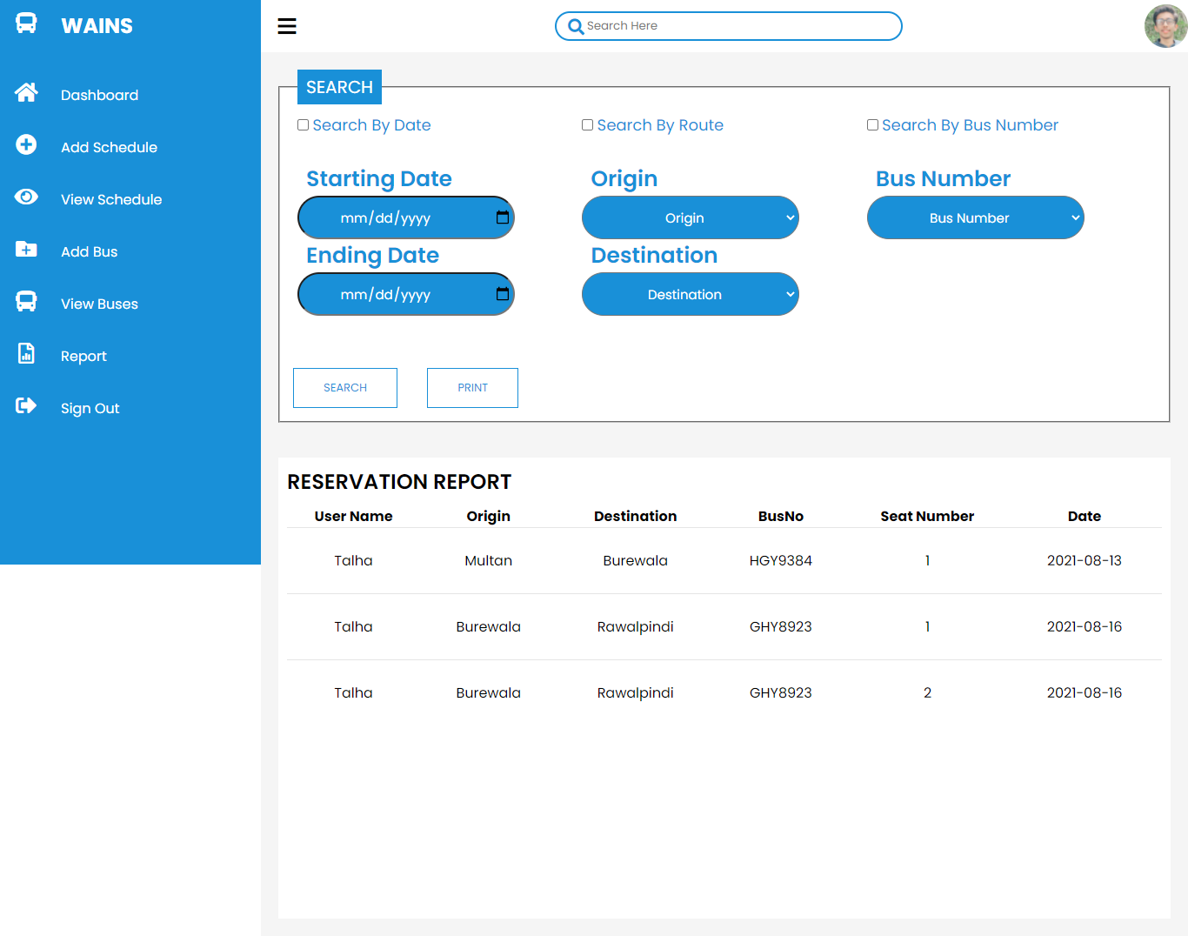

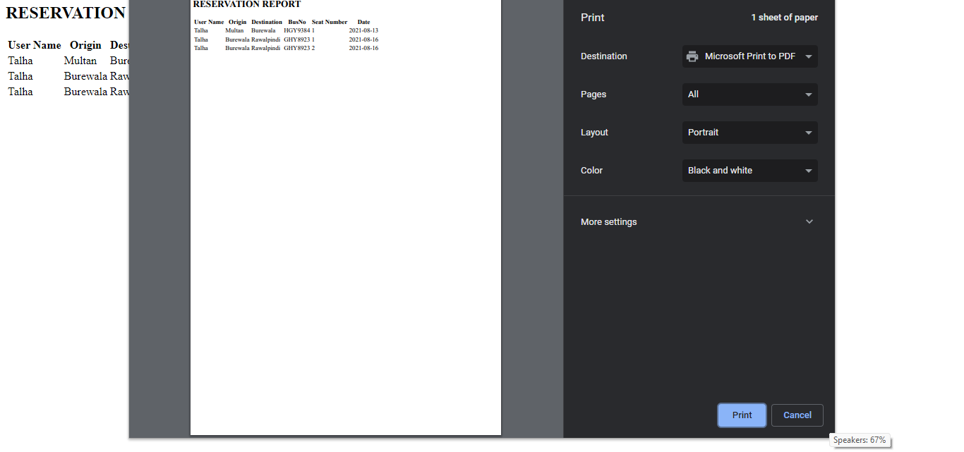Now Admin can also print the report just by clicking on “PRINT”

Chapter 6

Conclusion

# 6.1 Conclusion

The System of **WAINS TRANSPORT** has been computed successfully and was tested successfully by taking the “Test Cases”. It is user friendly, and has required options, which can be utilized by the user to perform the desire operation. The System has been designed keeping in view the present and future requirement in mind and made very flexible. The goals that are achieved by the software are instant access, improved productivity, optimum utilization of resources, efficient management of resources, simplification of the operation, less processing time and getting required information, user friendly, portable and flexible for the further enhancement.

****Bibliography****

<https://www.fontawesome.com/>

<https://www.github.com/>

<https://www.w3schools.com/php/>

<https://www.fonts.google.com/>